Timing of Respiratory Epidemics Driving Seasonal Influenza-like Illness in the United States

George Dewey, PhD, MPH^{1,2}; Austin G. Meyer, MD, PhD^{1,2,3}; Mauricio Santillana, PhD^{1,2,4}

Affiliations:
¹ Machine Intelligence Group for the Betterment of Health and the Environment, Northeastern University, Boston, MA, USA, 02115;
² Network Science Institute, Northeastern University, Boston, MA 02115, USA;
³ Baylor Scott and White Health, Dallas, TX 75426, USA;
⁴ Department of Epidemiology, Harvard T.H. Chan School of Public Health, Boston, MA, USA, 02115;

* Corresponding Author: Mauricio Santillana, 177 Huntington Ave Room 1023, Boston, MA 02115; m.santill@g.harvard.edu
E-mail: g.dewey@northeastern.edu (GD), austin.g.meyer@gmail.com (AM), m.santill@g.harvard.edu (MS)

Keywords: disease surveillance, RSV, influenza, influenza-like illness, forecasting, pandemic preparedness
Abstract

The seasonality of influenza-like illness (ILI) epidemics in the United States is well-established, with peak ILI activity generally occurring between December and February every year. However, the timing of the specific respiratory infections which contribute to the overall trajectory of each ILI season is not well understood. While traditional wisdom suggests that ILI seasons are initiated by epidemics of influenza A and followed by epidemics of influenza B, we use state-level surveillance data from the Centers from Disease Control and Prevention to show that epidemics of respiratory syncytial virus (RSV) reach their peak intensity before epidemics of influenza in over half of the last 8 ILI seasons. Improving our understanding of the temporal order of distinct respiratory infections will lead to improvements in preparedness for future outbreaks and increased understanding of the complex dynamics driving seasonal ILI.
Introduction

Influenza-like illness (ILI) affected between 9 and 41 million individuals in the United States (US) between 2010 and 2023 (1) with approximately 8% of the US population having symptomatic ILI every year (2). While many ILI cases in the US are associated with mild respiratory symptoms and afflicted patients recover quickly, the immense volume of ILI cases can put unnecessary stress on both health infrastructure and medical providers. Given this information, it is surprising that misconceptions about the sequencing of the respiratory disease epidemics contributing to the overall seasonal volume of ILI cases continue to persist among researchers and health providers. While it is understood that the overall trajectory of an individual ILI season represents the accumulation of multiple epidemics, conventional belief attributes these epidemics to mainly different strains of influenza; however, this belief likely stems from a historical leaning by public health surveillance systems towards influenza surveillance. Although a majority of ILI cases are attributable to influenza, many ILI cases are caused by non-influenza respiratory pathogens such as respiratory syncytial virus (RSV), rhinoviruses, parainfluenza virus, human pneumovirus, and coronaviruses including those causing coronavirus disease 2019 (COVID-19) (3). Given this wide variety of potential sources of ILI, the temporal ordering of influenza epidemics and epidemics of non-influenza diseases is unclear, especially in the US.

Anticipating the timing of respiratory epidemics, especially the beginning of ILI seasons and the epidemics driving the start of each season, has important implications for public health. One goal of continuous ILI surveillance and forecasting is to provide healthcare workers and healthcare facilities with timelines for resource allocation and allow for preparation for incoming waves of patients afflicted with respiratory symptoms. In addition to bolstering health infrastructure, proper anticipation of impending epidemics is vital for the timely distribution of prophylactics and vaccinations. For example, RSV prophylaxis for infants (a high-risk group for serious RSV infection) using the monoclonal antibody nirsevimab must be administered before the onset of an infant's first RSV season; infants born during the RSV season should receive nirsevimab within a week of birth (4). Prediction of the start of the RSV season would allow healthcare facilities to increase stock of the prophylactic well before a surge in RSV cases occurs.

To better understand how ILI seasons begin, we use time series analysis methods to determine the timing of respiratory outbreaks in the United States and highlight how many epidemics of RSV at the state level corresponded with the start of the ILI season in those states. We show that in such state-ILI seasons, the peak volume of RSV hospitalizations occurs before the peak volume of influenza hospitalizations. We also demonstrate that the presence of COVID-19 during the 2019-2020, 2021-2022, and 2022-2023 ILI seasons substantially affected the seasonality and duration of epidemics of both RSV and influenza. These analyses reinforce our argument that RSV epidemics "kick off" ILI seasons and show that the RSV outbreaks are followed by outbreaks of other respiratory epidemics such as influenza A, influenza B or COVID-19.

Results

In 32 out of 52 (61.5%) state-seasons, seasonal RSV volume reached peak intensity before the seasonal influenza (Figure 1). Peak ILI activity generally occurred between November and February each season, corresponding with epidemics of RSV, influenza, or synchronous increases in the volume of both infections. There were two main exceptions to this pattern. First, the 2019-2020 ILI season was significantly impacted by the onset of the COVID-19 pandemic in March 2020, resulting in a dramatic increase in COVID-19 volume and a corresponding steep decline in both reported RSV and reported influenza volume to near-zero values. This flattening extends throughout the 2020-2021 ILI season, with all analyzed states reporting little to no hospitalizations attributable to either RSV or influenza. In the 2021-2022 influenza season, we observed a deviation from the usual seasonal ILI pattern; in this season, we observed increases in ILI activity in both summer 2021 (July - September) and spring 2022 (March - May). The summer 2021 increase in ILI activity was fueled by overlapping RSV and COVID-19 outbreaks, while the spring 2022 ILI outbreak was driven by increases in influenza infections.

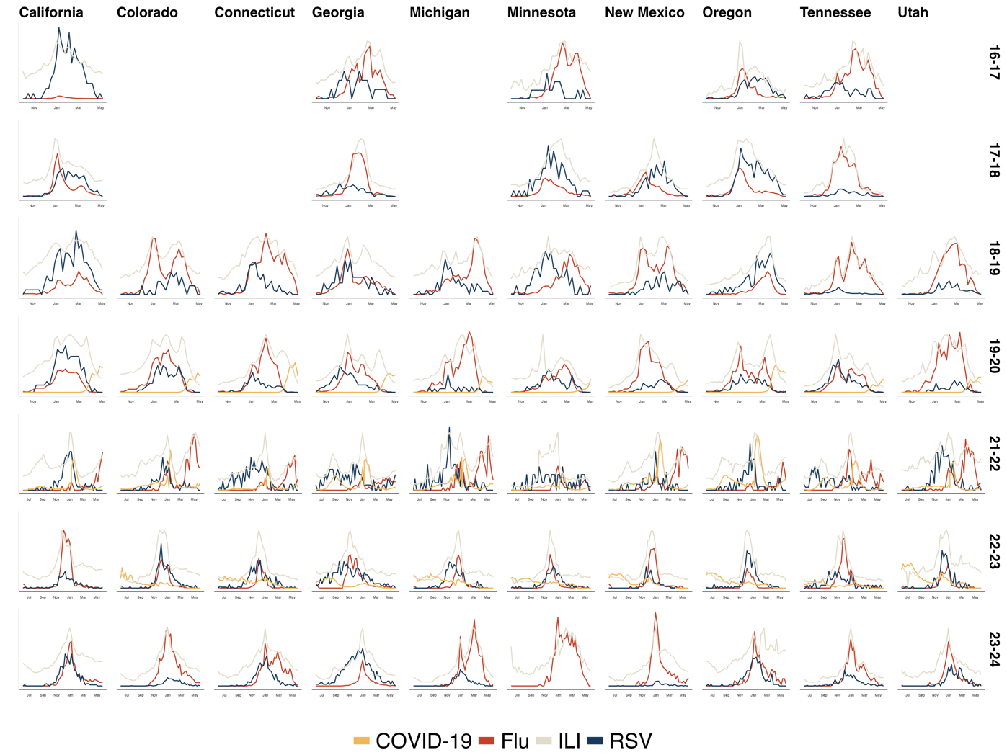
Figure 1. Variation in the peak timings of RSV, Influenza, and COVID-19 between the 2016-2017 ILI season and the 2023-2024 ILI season. Curves were generated using a stacked regression scheme using the LASSO estimator as the underlying model such that the maximum value of each curve for an individual plot indicates the peak volume of hospitalizations or outpatient visits for each disease. Date ranges in the first 4 years are shorter than those in the latter 3 years due to changes in data reporting structures. Abbreviations - COVID-19: coronavirus disease 2019, flu: influenza, ILI: influenza-like illness, RSV: respiratory syncytial virus
We also observed variable strength of respiratory epidemics in individual states. In California, RSV hospitalizations offered the strongest signal in 6 out of 9 seasons, while in states such as Colorado, Connecticut, Georgia, Michigan, Tennessee, and Utah, influenza hospitalizations had the strongest signal in most seasons. Similarly, there was variation in the timing of peaks within each infection type; influenza volume generally peaked in late December or early January, while RSV demonstrated a wider range of peak times, ranging from October (Minnesota and Connecticut in 2021-2022) to March (New Mexico in 2018-2019).

Considering the dramatic deviation from normal seasonal patterns caused by the COVID-19 pandemic, we evaluated if the temporal relationship between RSV and influenza peaks differed before and after the pandemic. We divided the ILI seasons into a pre-pandemic period (2016-2017, 2017-2018, and 2018-2019 seasons) and post-pandemic period (2022-2023, 2023-2024 seasons) and again calculated the number of state-seasons in which RSV peaked before influenza. We found that during the pre-pandemic period, 11 out of 22 (50%) of state-seasons had RSV peak before influenza, while in the post-pandemic period, only 6 out of 20 (30%) of state-seasons had RSV peak before influenza.

Discussion

Our finding that RSV epidemics initiated many of the recent ILI seasons in the United States has significant implications for public health authorities, medical providers, and healthcare facilities. Identifying increases in RSV hospitalizations as a signal for the start of the yearly ILI season and understanding the possible early start (i.e., before December or January) of seasonal RSV epidemics should improve the preparedness of healthcare workers and facilities before patient volume exceeds the capacity of health infrastructure. Our findings concur with those of past studies evaluating the timing of RSV and influenza epidemics in Argentina (5) and on the global scale (6) which identified that RSV epidemics in temperate regions occurred before influenza epidemics. These results promote future research into the accurate timing and anticipation of respiratory epidemics, especially the development of new predictive tools which can take advantage of the immense number of data streams available through modern technologies.

It is notable that the clearest temporal ordering for the different respiratory outbreaks occurred during the 2022-2023 ILI season, as one would expect that the co-circulation of an additional respiratory disease (COVID-19) would negatively impact surveillance of others like RSV or influenza. However, we expect that increased testing for respiratory infections and heightened scrutiny of respiratory disease-related hospitalization in fact led to improved surveillance during that ILI season.

There are several limitations to this study. Our analysis was limited to only the 10 states that supplied data to both CDC respiratory illness surveillance systems: CDC ILINet and CDC RESP-NET. These states have historical data for both ILI volume and RSV or influenza infection volume in time periods both pre- and post-COVID-19 pandemic, allowing us to make comparisons and determine if post-COVID-19 seasonal outbreak patterns returned to pre-pandemic levels. The availability of RSV, influenza, and COVID-19 data for all 50 states is available through the CDC's National Syndromic Surveillance Program (7)but this initiative was only started after the COeVID-19 pandemic and therefore has only data collected starting in the 2022-2023 ILI season. We also acknowledge that our regression algorithm does not account for the presence of other epidemics such as those caused by HMPV or PIV; however, these diseases are milder among adults and are unlikely to burden healthcare systems as RSV or influenza do.

Materials and Methods

Data sources. Our analyses utilize publicly available data collected by two major CDC surveillance systems: the US Outpatient Influenza-like Illness Surveillance Network (ILINet) and the Respiratory Virus Hospitalization Surveillance Network (RESP-NET) (8). ILINet is a collaboration between national, state, and local health departments and healthcare facilities that records the volume of hospital visits for any influenza-like illness and submits those records to the CDC for centralized data storage. RESP-NET is a combination of three surveillance systems which cover the three main respiratory infections covered in this report: FluSurv-NET (monitoring influenza), COVID-NET (monitoring COVID-19) and RSV-NET (monitoring RSV). Since we were primarily interested in the temporal ordering comparing RSV and influenza, we restrict our analyses to only the states reporting to RSV-NET (9) which monitors laboratory-confirmed, RSV-associated hospitalizations among children and adults. RSV-NET began tracking RSV hospitalizations among adults in the 2016-2017 season and comprises 161 counties and county equivalents in 13 states participating in the Respiratory Virus Surveillance Network. RSV-NET covers more than 30 million people and includes an estimated 9% of the US population. We restrict our analysis to only hospitalizations among adults to ensure that the maximum amount of available data was incorporated.

We measure the overall intensity of each ILI season using data from ILINet. ILINet data is presented as the percentage of all outpatient visits for influenza-like illness as reported by sentinel sites. We also measure the case volume of influenza, COVID-19, and RSV using the RESP-NET dataset (7). Data from RESP-NET is reported as the percent of all emergency department visits by age group associated with each infection type. For example, a value of 6.5% for influenza for adults aged 18 and over indicates that 6.5% of all emergency department visits for adults aged 18 and over were associated with influenza infections.

Our final analysis incorporated 62 state-ILI seasons, with data aggregated at the weekly level. During the 2016-2017 ILI season, only 5 states (California, Georgia, Minnesota, Oregon, and Tennessee) supplied both flu and RSV hospitalization data. In the 2017-2018 season, those 5 states were joined by New Mexico. For the following 5 ILI seasons (2018-2019, 2019-2020, 2021-2022, 2022-2023, and 2023-2024), we had hospitalization and ILI data for 10 states (the previously noted 6 states in addition to
Colorado, Connecticut, Michigan, and Utah). We exclude the 2020-2021 ILI season from analysis because almost all records included no volume of either influenza or RSV-associated hospitalizations but an immensely high volume of COVID-19 associated hospitalizations. We additionally exclude 3 RSVNET member states from analysis (New York, Maryland, and North Carolina). New York data was excluded because only 2 counties supplied data. We exclude Maryland and North Carolina because these states did not report influenza data.

Data analysis. We used a stacked regression (10) scheme to evaluate how the intensity of individual respiratory outbreaks contributed to the overall trajectory of each ILI season across the analyzed states. We first filtered the data to generate individual datasets for each state-ILI season, where each ILI season begins in May of one year and ends in June of the following year. Next, we used a rescaling algorithm to take the signal characterized by each time series and constrain it to the range [0, 1], where 1 represents the maximum signal strength and 0 represents the minimum signal strength. The algorithm takes the value of each signal at each time point and divides it by the maximum signal value for each ILI season.

We next run a LASSO regression, using 10-fold cross validation to identify the best lambda value. The regression formula for each state-season is:

$$ILI=β_{flu}t+β_{RSV}t+β_{COVID}t+ϵ$$

where ILI is the rescaled ILI volume for the timepoint t in each state and ε is a generic error term. For these regressions, we use the penalized R package( 11) to remove the intercept and constrain predicted values for each individual predictor to be positive. We then take the beta coefficients from the LASSO model and multiplied them by the values of the rescaled ILI/hospitalization curves to obtain the time series shown in Figure 1. Finally, we used those signal curves to identify the ILI seasons where peak RSV intensity occurred before peak influenza intensity; that is, when $t_{peak RSV}<t_{peak flu or peak COVID}$.

Acknowledgements
This work was supported in part by the Centers for Disease Control and Prevention’s Center for Forecasting and Outbreak Analytics (CFA) cooperative agreement CDC-RFA-FT-23-0069. Data and code used in this article are available at github.com/XXXX and were obtained from HealthData.gov.

References

1. Centers for Disease Control and Prevention. Influenza - About Estimated Flu Burden 2025 [Available from: https://www.cdc.gov/flu-burden/php/about/index.html].
2. Tokars JI, Olsen SJ, Reed C. Seasonal Incidence of Symptomatic Influenza in the United States. Clin Infect Dis. 2018;66(10):1511-8.
3. Spencer JA, Shutt DP, Moser SK, Clegg H, Wearing HJ, Mukundan H, et al. Distinguishing viruses responsible for influenza-like illness. Journal of Theoretical Biology. 2022;545:111145.
4. American Academy of Pediatrics. Nirsevimab Administration 2024 [Available from: https://www.aap.org/en/patient-care/respiratory-syncytial-virus-rsv-prevention/nirsevimab-administration/.
5. Baumeister E, Duque J, Varela T, Palekar R, Couto P, Savy V, et al. Timing of respiratory syncytial virus and influenza epidemic activity in five regions of Argentina, 2007-2016. Influenza Other Respir Viruses. 2019;13(1):10-7.
6. Li Y, Reeves RM, Wang X, Bassat Q, Brooks WA, Cohen C, et al. Global patterns in monthly activity of influenza virus, respiratory syncytial virus, parainfluenza virus, and metapneumovirus: a systematic analysis. The Lancet Global Health. 2019;7(8):e1031-e45.
7. HealthData.gov. NSSP Emergency Department Visits - COVID-19, Flu, RSV, Combined – by Demographic Category 2025 [Available from: https://healthdata.gov/dataset/NSSP-Emergency-Department-Visits-COVID-19-Flu-RSV-/vfw5-fbqw/about_data.
8. Centers for Disease Control and Prevention. Respiratory Virus Hospitalization Surveillance Network (RESP-NET) 2025 [Available from: https://www.cdc.gov/resp-net/dashboard/index.html.
9. Centers for Disease Control and Prevention. RSV-NET - Respiratory Syncytial Virus Infection (RSV) 2025 [Available from: https://www.cdc.gov/rsv/php/surveillance/rsv-net.html.
10. Breiman L. Stacked regressions. Machine Learning. 1996;24(1):49-64.
11. Goeman J. Penalized: L1 (lasso and fused lasso) and L2 (ridge) penalized estimation in GLMs and in the Cox model. 0.9-52 ed2022.

